import wooldridge as woo

import numpy as np

import pandas as pd

import seaborn as sns

import matplotlib.pyplot as plt

from stargazer.stargazer import Stargazer

import statsmodels.formula.api as smf

# load data named <dataset> and save it in an object with the same name

meap93set = woo.dataWoo("meap93")[["salary", "benefits", "enroll", "droprate"]]

meap93set.**describe()**

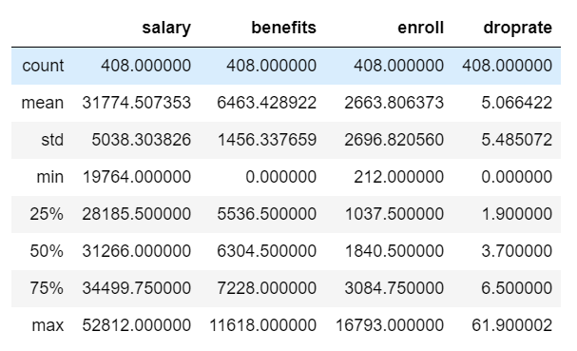

* 

data = woo.dataWoo('meap93')

data['b_s']=data['benefits']/data['salary']

model1= smf.ols(formula='np.log(salary) ~ b_s', data=data).fit()

model2= smf.ols(formula='np.log(salary) ~ b_s + np.log(enroll) + np.log(staff) ', data=data).fit()

model3= smf.ols(formula='np.log(salary) ~ b_s + np.log(enroll) + np.log(staff) + droprate + gradrate', data=data).fit()

st = **Stargazer**([model1, model2, model3])

#***change title***

st.**title**("These are awesome titles")

#***change column names***

st.**custom_columns**(['model1', 'model2', 'model3'], [1,1,1])

#rename covariates

st.**rename_covariates**({"b_s" : "Benefits Salary Ratio"})

#add notes at the bottom

st.**custom_note_label**("Some label that I want to add \n")

**from IPython.display import HTML**

**HTML(st.render_html())**

